Intelliware 1.0 setup
Assignment 2

For the Intelliware 1.0 software package we came up with this design:

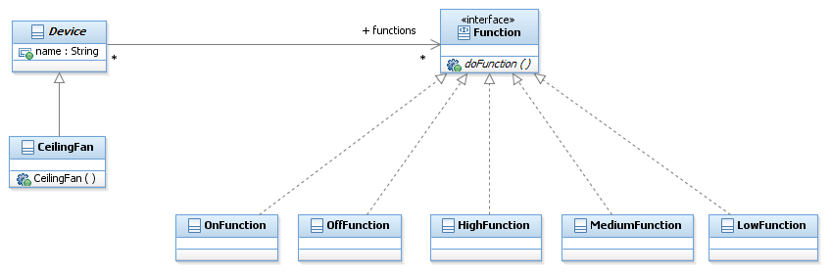
This means we have specific devices such as a Ceilingfan or TV inheriting from a GenericDevice class. The GenericDevice class has an ArrayList with the interface class-type GenericFunction which is then filled with specific implementations of functions. The amount and type of functions are determined by the specific device classes.
There are also specific Function classes such as: On/Off, Notify, SetVolume etc.
The specific Function classes implement a Function interface, so that every functionclass has one specific method: doFunction(). This method allows a class to do what it is supposed to do. For example: turning on/off a device, setting the volume, changing the channel etc.
With this design, which you could call a modular set up. It is easy to add new specific devices, supply them with existing functions or add new functions for the device and other new or existing devices to perform.

